BPAY LOGO – DOES NOT ACCEPT CREDIT CARDS
(vertical format)

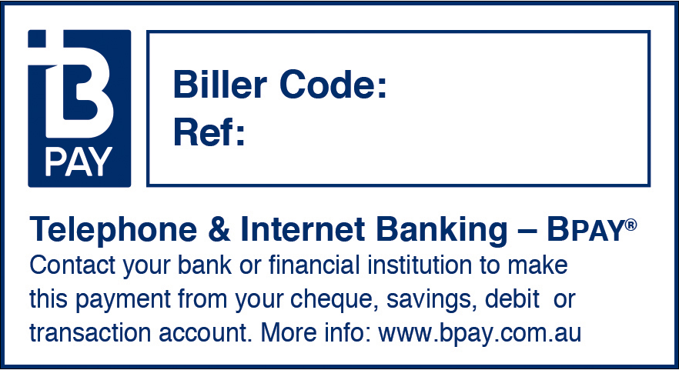

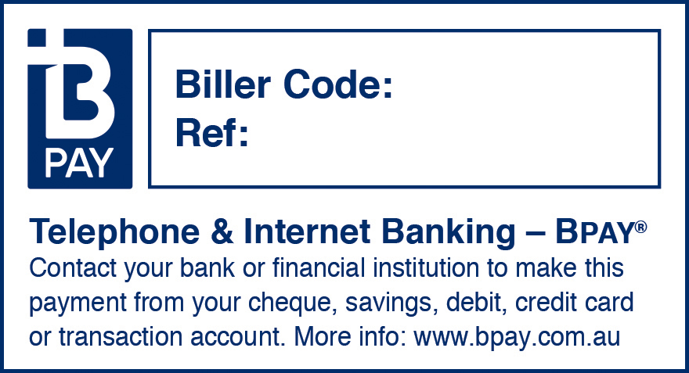
BPAY LOGO – DOES ACCEPT CREDIT CARDS
999999
9999999
(vertical format)

BPAY LOGO – DOES NOT ACCEPT CREDIT CARDS
(horizontal format)

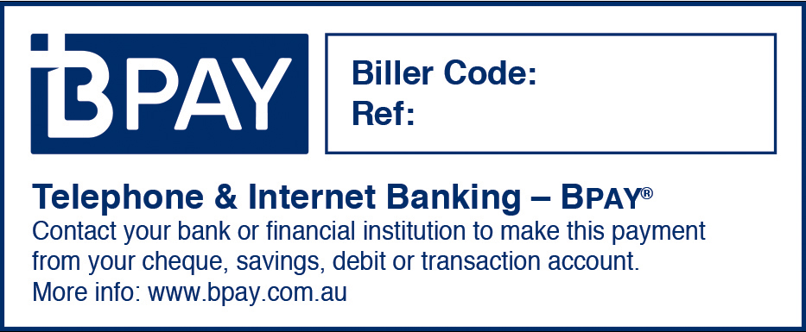
999999
9999999

BPAY LOGO – DOES ACCEPT CREDIT CARDS
(horizontal format)

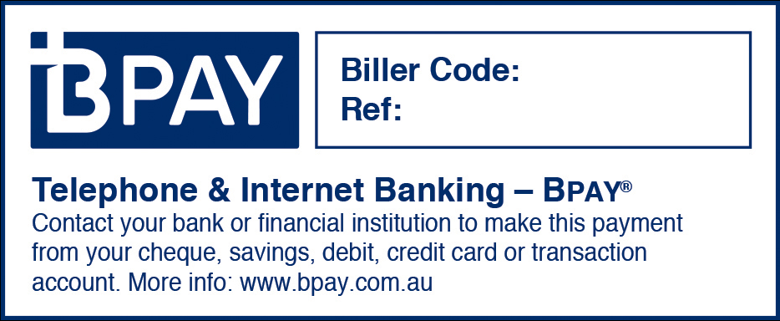
999999
9999999

